
Module Code | : | CT080-3-2 Ethical Hacking and Incident Response
Intake Code | : | APD2F2509CS(CYB)
Lecturer Name | : | TS. MOHD NORFAHMI BIN JAAFAR
Hand in Date / Date Due | : | Week 13 - 31 May 2026, 11:59pm
Hand out Date / Date Assigned | : | Week 7 - 8 April 2026
Group Name | : | Group X
Group Leader | : | AHMED MIRAHUSAIN ALVI
Topic Title | : | Ransomware Infection via Social Engineering

Student ID | Student Name
TP084807 | AHMED MIRAHUSAIN ALVI
TP085327 | SULTAN ABDULLA OMAR TAKRORI
TP085562 | MAHRUS SHAMSUL AHSAN
TP085097 | ABDALLAH MOHAMED MAHMOUD MOHAMED MAHMOUD
TP085042 | MOHAMMED YOUSEF MOHAMMED MOHAMMED
TP082459 | MOHAMED ABDIFATAH ALI

Group Contribution Summary
This is a group submission. The table below clearly records the contribution of each member so that the report matches the group submission requirement and shows how the work was divided.
Student ID | Student Name | Contribution | Evidence in Report
TP084807 | AHMED MIRAHUSAIN ALVI | Group leader; report coordination; case overview; final checking. | Cover, introduction, case overview.
TP085327 | SULTAN ABDULLA OMAR TAKRORI | Ransomware background, social engineering scenario, malware behaviour. | Sections 2.1-2.3.
TP085562 | MAHRUS SHAMSUL AHSAN | Memory image explanation, MemProcFS setup, analysis environment. | Sections 3.1-3.3 and mount evidence.
TP085097 | ABDALLAH MOHAMED MAHMOUD MOHAMED MAHMOUD | Host identification, network connections, Defender alert, timeline validation. | Sections 4.1, 5.1-5.3.
TP085042 | MOHAMMED YOUSEF MOHAMMED MOHAMMED | MFT/Prefetch, encryption log, RSA key analysis, OpenSSL verification. | Sections 5.4-5.6.
TP082459 | MOHAMED ABDIFATAH ALI | Countermeasures, IOC table, references, appendices and formatting. | Sections 6-8 and Appendix A.

TABLE OF CONTENTS
Group Contribution Summary 2
1.1 Case Overview 4
2.1 Ransomware Overview 5
2.2 Attack Scenario 5
2.3 Malware Behaviour 6
3.1 What is a Memory Dump? 7
3.2 About This Memory Image 7
3.3 Analysis Environment Setup 8
3.3.1 Mounting the Image with MemProcFS 8
3.3.2 Volatility 3 Alternative Commands 9
4.1 Chronological Timeline of Events 10
4.2 Attack Chain Diagram 10
DETAILED ANALYSIS OF FINDINGS 13
5.1 Host Identification 13
5.2 Network Connections & Malicious Download 14
5.3 Windows Defender Alert — Malware Identification 15
5.4 Execution Evidence — MFT & Prefetch 16
5.5 Encryption Activity — encryption_log.txt 17
5.6 RSA Key Analysis — Public Key & Private Key Recovery 18
5.6.1 Public Key 18
5.6.2 Private Key Recovery from RAM 19
5.7 Browser History & Social Engineering Evidence 21
5.8 Summary of Key Findings 23
CONCLUSION AND COUNTERMEASURES 24
6.1 Conclusion 24
6.2 Countermeasures and Recommendations 25
6.2.1 Technical Controls 25
6.2.2 User Awareness Controls 25
6.2.3 Incident Response Controls 25
REFERENCES 26
APPENDICES 27
Appendix A: Indicators of Compromise (IOC) Summary 27

INTRODUCTION
This group report documents the memory forensics investigation of a Windows workstation compromised by ransomware. The incident was triggered through social engineering, where the victim was persuaded to download and run a malicious binary disguised as backup software. The report follows a group submission format, includes member contributions, and focuses on incident handling findings from the infected memory image.

Memory forensics is critical in incident response because volatile memory can reveal artefacts that are unavailable from disk alone, including active processes, network connections, file handles, injected code, and encryption material. NIST guidance also highlights the importance of collecting and analysing forensic data during incident response (Kent et al., 2006; Cichonski et al., 2012).

This report is structured to address the following objectives:
1. Provide background on the ransomware attack scenario.
2. Explain the nature of the memory image under investigation.
3. Reconstruct the timeline of how the incident occurred.
4. Present detailed forensic analysis findings from the infected machine.
5. Identify indicators of compromise (IOCs) and recommend countermeasures.

1.1 Case Overview

Case Title | Ransomware Infection via Social Engineering — 13Cubed Windows Memory Forensics Challenge
Memory Image | memory.dmp (Windows memory dump)
Analysis Tool | MemProcFS v5.17.7 (Windows) — mounts image as virtual drive M:\
Infected Machine | Hostname: RM-205B | IP: 10.0.2.152
Primary User | Robert Paulson
Incident Date | 2025-03-07
Malware Type | Custom Ransomware (Trojan:Win32/Wacatac.B!ml)
Files Encrypted | 9 files
BACKGROUND OF THE CASE / ATTACK

2.1 Ransomware Overview

Ransomware is a category of malware that encrypts the victim's files and demands a ransom payment — typically in cryptocurrency — in exchange for the decryption key. Modern ransomware often employs asymmetric encryption (RSA) to protect the symmetric key used to encrypt files, making decryption without the attacker's private key computationally infeasible.

Ransomware attacks have grown significantly in sophistication, with threat actors (TAs) increasingly leveraging legitimate-looking delivery mechanisms to increase infection rates. Drive-by downloads, phishing emails, and fake software landing pages are among the most common delivery vectors.

2.2 Attack Scenario

The incident investigated in this report involves an employee named Robert Paulson who recently joined a new company. Upon hearing about ransomware attacks, he attempted to back up his data by searching online for a free backup utility for Windows 11.

His search led him to a malicious website impersonating a legitimate software vendor. The fake page was titled 'Backup Pro: Secure Your Files' and used urgency and reassurance to persuade the user to download backup.exe. The instruction to exclude C:\ from antivirus scanning was a social engineering tactic: it attempted to make the victim weaken endpoint protection before running the malware.

Social Engineering Tactic: The fake landing page instructed users to exclude the C:/ drive from antivirus scanning a deliberate attempt to suppress Windows Defender and allow the malware to execute undetected.

2.3 Malware Behaviour

The malicious binary (backup.exe) performed the following actions upon execution:
1. Generated an RSA public/private key pair.
2. Transmitted data to the attacker's Command & Control (C2) server at 167.172.227.148.
3. Encrypted 9 files on the victim's machine using the generated key pair.
4. Wrote an encryption log (encryption_log.txt) to the victim's Desktop.
5. Stored the public key in the user's Temp directory.

Note: Although Windows Defender flagged backup.exe during download (2025-03-07 19:37:27 UTC) as Trojan:Win32/Wacatac.B!ml, the user proceeded to execute the file approximately 4 minutes later.

EXPLANATION OF THE SELECTED MEMORY IMAGE

3.1 What is a Memory Dump?

A memory dump (also called a memory image or RAM dump) is a complete snapshot of the contents of a computer's volatile memory (RAM) at a specific point in time. Unlike data stored on a hard disk, RAM is volatile — meaning its contents are lost when the machine is powered off. Capturing a memory dump therefore preserves critical forensic artefacts that would otherwise be unrecoverable.

Memory dumps can contain:
1. Running and recently terminated processes and their associated memory spaces.
2. Open network connections and sockets.
3. Loaded DLLs and kernel modules.
4. Command history and clipboard contents.
5. Encryption keys and credentials stored in memory.
6. Injected code and shellcode that may not exist on disk.

3.2 About This Memory Image

Filename | memory.dmp
Source OS | Windows (Workstation — confirmed by presence of Prefetch files)
Acquisition Context | Forensic capture of a compromised Windows workstation
Image Source | 13Cubed Windows Memory Forensics Challenge (educational)
Tool Used | MemProcFS v5.17.7 (Windows) — mounts image as virtual drive M:\
Secondary Tool | Volatility 3 — for plugin-based analysis
Challenge Download | https://cdn.13cubed.com/downloads/windows_challenge.zip

The memory image was acquired from the workstation of Robert Paulson (RM-205B) shortly after the ransomware infection. Because the machine is a Windows workstation (not a server), Prefetch files are present these are execution artefacts stored in C:\Windows\Prefetch\ that record evidence of program launches and are absent on Windows Server installations.

3.3 Analysis Environment Setup

3.3.1 Mounting the Image with MemProcFS

MemProcFS v5.17.7 was used as the primary analysis tool on Windows. MemProcFS presents physical memory as a mounted virtual file system, allowing investigators to browse processes, registry hives, network connections, and forensic artefacts using ordinary folders and files (ufrisk, 2026). Dokany was installed as a prerequisite for the virtual filesystem mount.

"C:\Users\abdul\iCloudDrive\APU Year 2 Sem 2\MemProcFS\MemProcFS.exe"
-device "C:\Users\abdul\iCloudDrive\APU Year 2 Sem 2\windows_challenge\memory\memory.dmp"
-forensic 1

Upon successful mount, MemProcFS outputs the following confirmation:
Figure 1 - MemProcFS Mount Confirmation

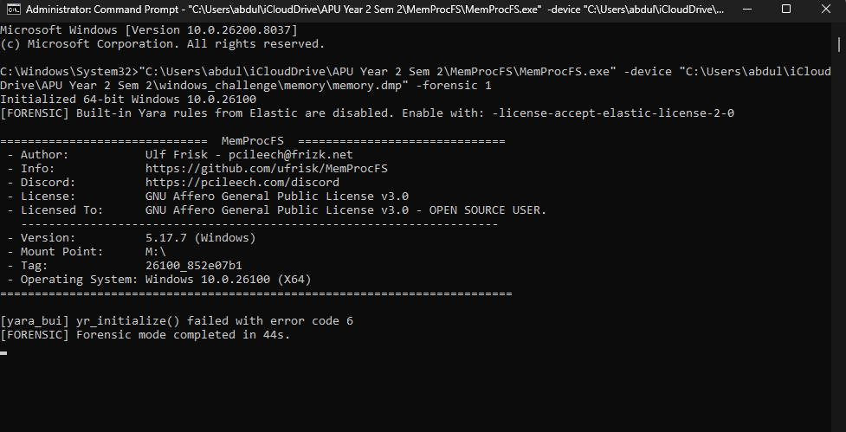
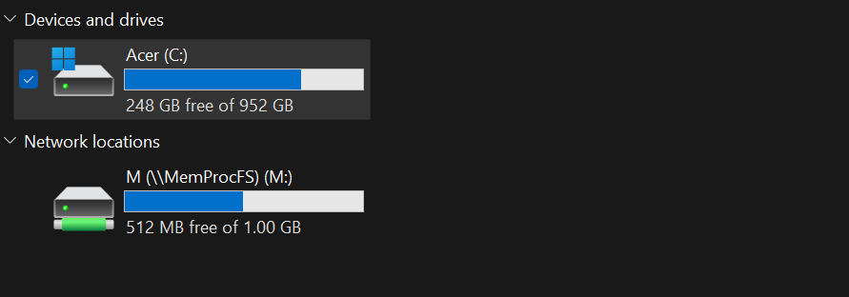

Explanation: This screenshot evidence confirms that the memory image was mounted successfully as M:\ in forensic mode. This is important because all later findings, including host details, network artefacts, MFT entries, Defender alerts, and recovered files, were accessed from this mounted memory filesystem.

All file analysis commands were run from a second Administrator Command Prompt window while MemProcFS remained running in the first window. Git Bash was used for grep-based analysis of the raw memory dump (RSA key extraction).

3.3.2 Volatility 3 Alternative Commands

MemProcFS was the primary tool used for the findings in this report. Volatility 3 is listed only as an alternative validation approach because no separate Volatility output was used as primary evidence in the findings. The Volatility netscan plugin can scan Windows memory images for network objects, making it a useful cross-check when available (Volatility Foundation, 2026).
# List running processes
python vol.py -f memory.dmp windows.pslist
# Scan network connections
python vol.py -f memory.dmp windows.netscan
# List command-line arguments
python vol.py -f memory.dmp windows.cmdline
# Scan for files in memory
python vol.py -f memory.dmp windows.filescan

HOW THE INCIDENT OCCURRED – ATTACK TIMELINE
The following timeline was reconstructed using multiple forensic artefacts from the memory image, including the Master File Table (MFT), Prefetch files, Windows Defender event logs, registry entries, and network connection data.
Timezone note: Unless stated otherwise, forensic timestamps in this report are recorded in UTC. The encryption_log.txt entries display local workstation time, which is eight hours behind UTC in this dataset. Therefore, 2025-03-07 11:41:08 local corresponds to approximately 2025-03-07 19:41:08 UTC. This explains why the encryption timestamp appears different from the MFT and Defender timestamps.

4.1 Chronological Timeline of Events

Time (UTC) | Event
2025-03-07 19:37:27 UTC | Windows Defender detects backup.exe during download from 167.172.227.148:8080 and flags it as Trojan:Win32/Wacatac.B!ml (MPSOURCE_IOAV alert triggered). Confirmed via findevil.txt.
2025-03-07 19:40:36 UTC | backup.exe file CREATED on disk at C:\Users\Robert Paulson\Downloads\backup.exe (11,836,134 bytes). Confirmed via MFT timeline_ntfs.txt.
2025-03-07 19:41:04 UTC | backup.exe last MODIFIED on disk — SmartScreen metadata file also written at this time. Confirmed via MFT.
2025-03-07 19:41:08 UTC | First execution of backup.exe confirmed via creation of Prefetch file: BACKUP.EXE-AB6C9DDF.pf. RSA public key written to AppData\Local\Temp\tmp98p1q14j. TCP connection established to C2 server at 167.172.227.148:80 for key exfiltration.
2025-03-07 11:41:08 local | encryption_log.txt created on Desktop — ransomware encrypts 9 files in under 20ms (11:41:08.946 to 11:41:08.962). Note: local timezone differs from UTC timestamps in MFT.
2025-03-07 19:41:09 UTC | Prefetch file for backup.exe last modified — confirms continued execution.
2025-03-07 19:41:11 UTC | Registry entry written under InventoryApplicationFile for backup.exe — Windows application tracking records the execution.

4.2 Attack Chain Diagram

The diagram below illustrates the full attack chain from initial web search through to file encryption and the critical forensic finding of the private RSA key resident in memory. The left lane represents victim-side actions; the right lane represents attacker infrastructure. Arrows crossing the centre show communication between the two.

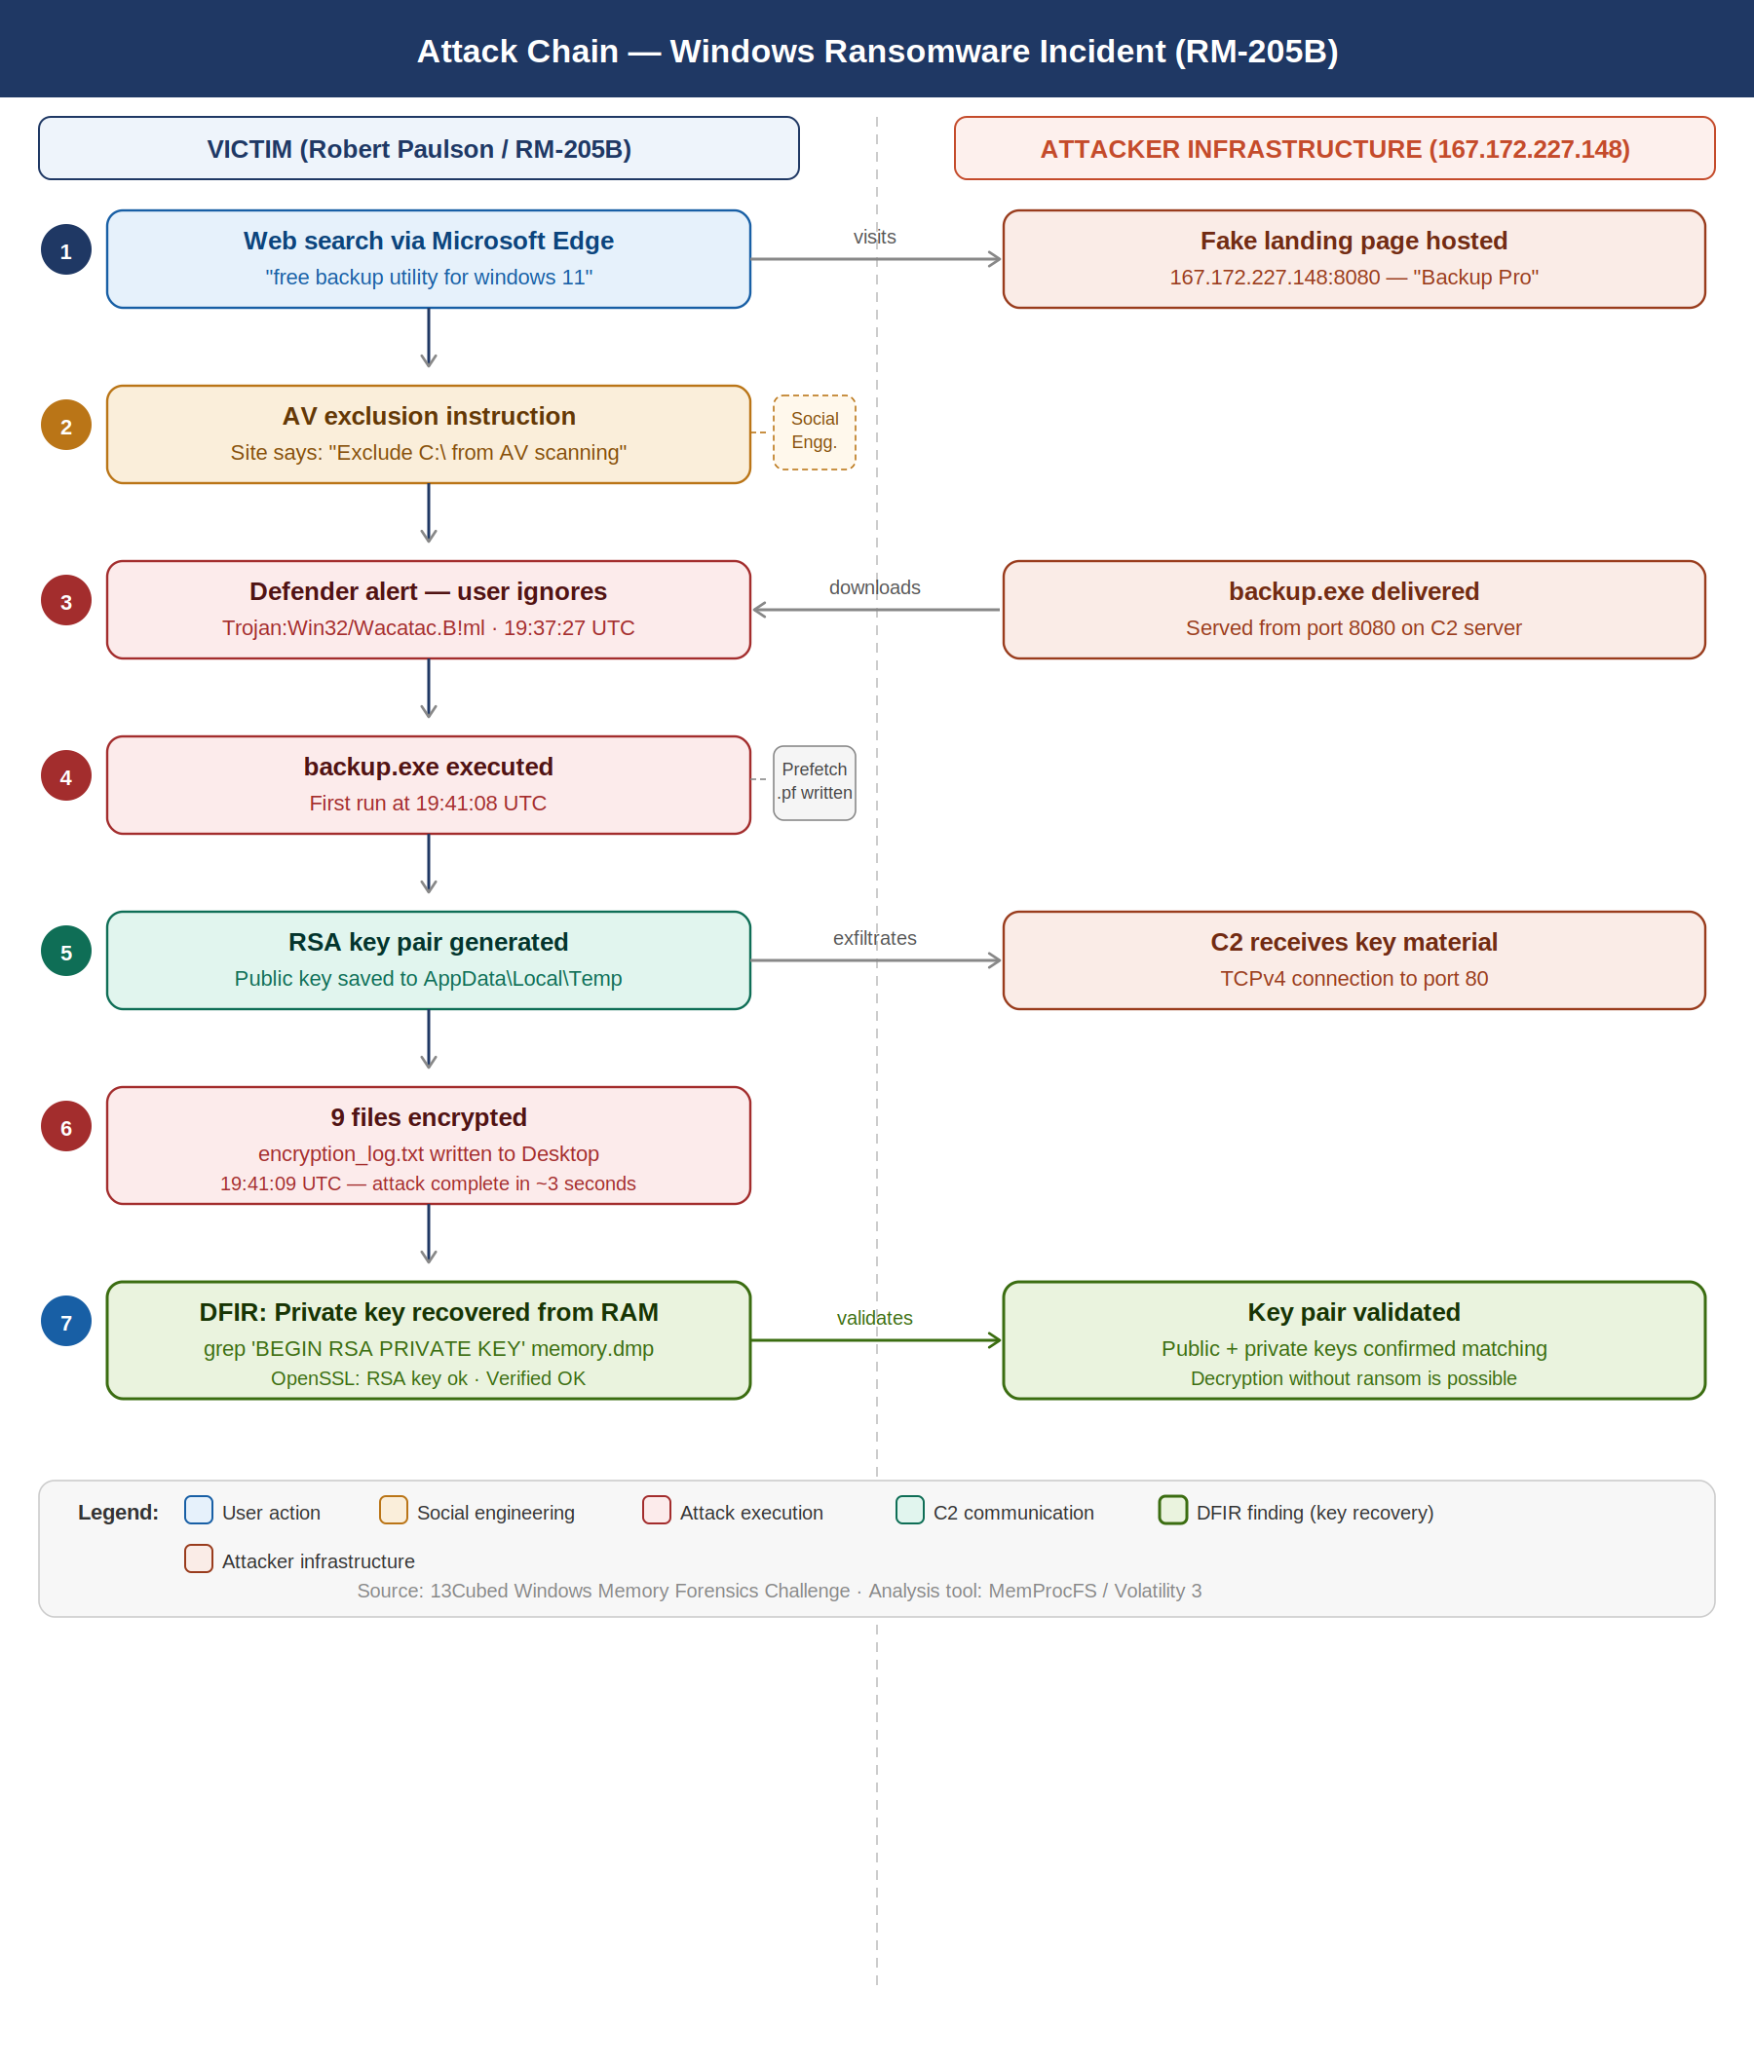
Figure 2 - Ransomware Attack Chain (7-step, victim vs attacker infrastructure)

DETAILED ANALYSIS OF FINDINGS
Each subsection below includes the relevant screenshot evidence directly beside the finding so that the examiner can verify the artefact without relying only on the appendix.

5.1 Host Identification

The hostname was retrieved from the MemProcFS system summary files:
$ cat /mnt/m/sys/computername.txt
RM-205B

The username was confirmed via the users list:
$ cat /mnt/m/sys/users/users.txt
0000 Robert Paulson S-1-5-21-2126657629-3337008557-1579520640-1001

The IP address was retrieved from network connections and validated against the registry:
$ cat /mnt/m/registry/HKLM/SYSTEM/ControlSet001/Services/Tcpip/Parameters/Interfaces/{...}/DhcpIPAddress.txt
10.0.2.152

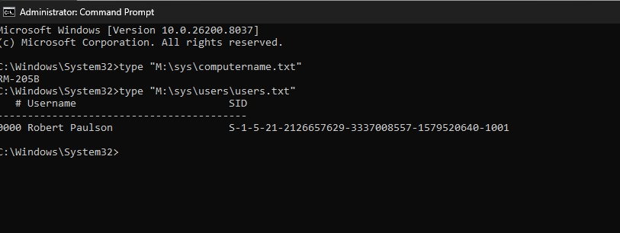
Figure 3 - Host Identification (computername.txt and users.txt)

5.2 Network Connections & Malicious Download

Network connections captured in memory showed TCP connections from Microsoft Edge (PID 8240) to an external IP on port 8080, confirming the malware download:
TCPv4 CLOSED 10.0.2.152:50070 167.172.227.148:8080 msedge.exe PID:8240
TCPv4 CLOSED 10.0.2.152:50071 167.172.227.148:8080 msedge.exe PID:8240
TCPv4 CLOSED 10.0.2.152:50079 167.172.227.148:80 backup.exe

The port 80 connection was established by backup.exe during execution, confirming C2 communication for RSA-related data transfer. The original parsed output did not reliably preserve a PID for backup.exe, so the PID field is not reported rather than using an unsupported placeholder.

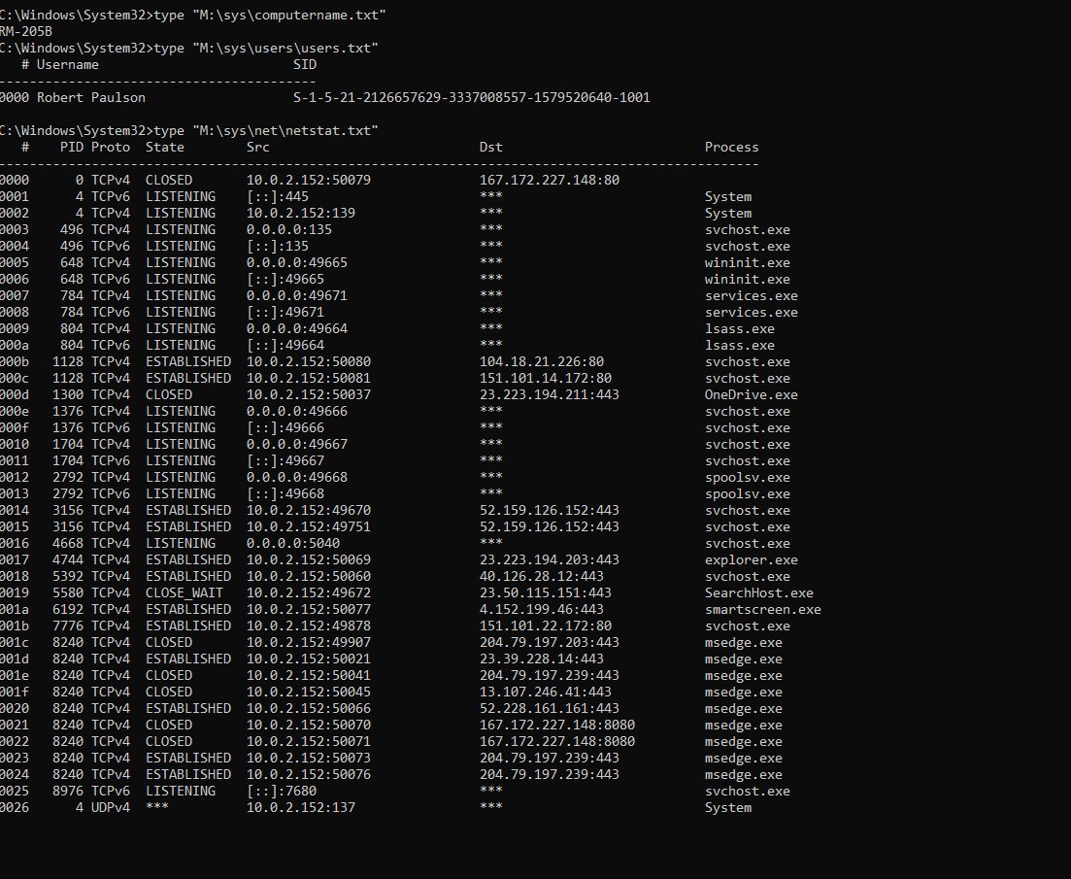
Figure 4 - Network Connections (netscan / netstat.txt)

5.3 Windows Defender Alert — Malware Identification

The Windows Defender FindEvil module in MemProcFS confirmed the full download URL, file path, and malware classification. This is relevant because Microsoft Defender Antivirus is designed to identify and block malware using signature, cloud-delivered, and behaviour-based protection (Microsoft, 2025).
AV:[Windows Defender] DETECTIONEVENT MPSOURCE_IOAV
Trojan:Win32/Wacatac.B!ml
file: C:\Users\Robert Paulson\Downloads\backup.exe
webfile: http://167.172.227.148:8080/backup.exe | pid:1452
Timestamp: 2025-03-07T19:37:27.387Z

This artefact is particularly significant — it establishes both the malware classification and the exact download URL from C2 infrastructure.

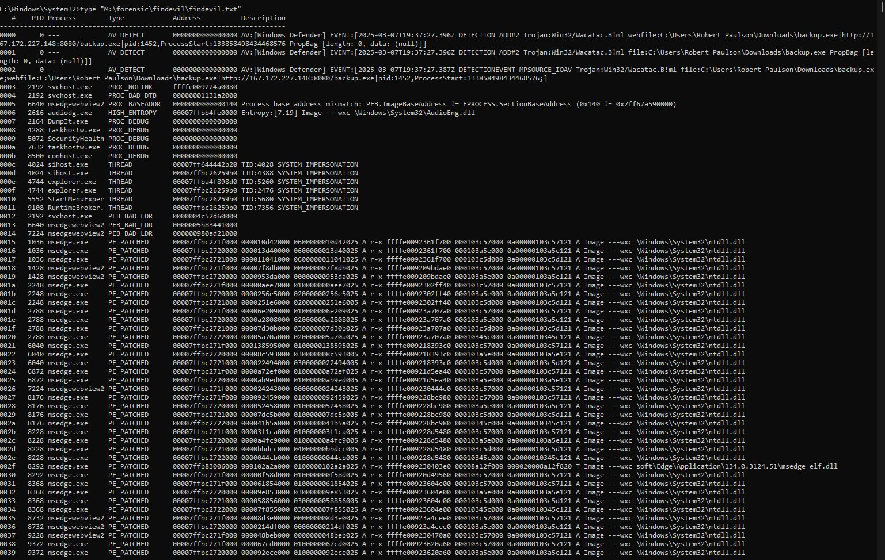
Figure 5 - Windows Defender FindEvil Alert

IOC: C2 Server IP = 167.172.227.148 | Download port 8080 | Key exfiltration port 80 | AV sig: Trojan:Win32/Wacatac.B!ml

5.4 Execution Evidence — MFT & Prefetch

Prefetch files are execution artefacts present on Windows workstation editions. They are valuable forensic artefacts because they help confirm program execution and timing. In this case, the creation of BACKUP.EXE-AB6C9DDF.pf at 19:41:08 UTC supports the first execution time:
$ cat /mnt/m/forensic/ntfs/ntfs_files.txt | grep -i backup
\Windows\Prefetch\BACKUP.EXE-AB6C9DDF.pf
Created: 2025-03-07 19:41:08 UTC
Modified: 2025-03-07 19:41:09 UTC
backup.exe in \Users\Robert Paulson\Downloads\
Created: 2025-03-07 19:40:36 UTC
Modified: 2025-03-07 19:41:04 UTC

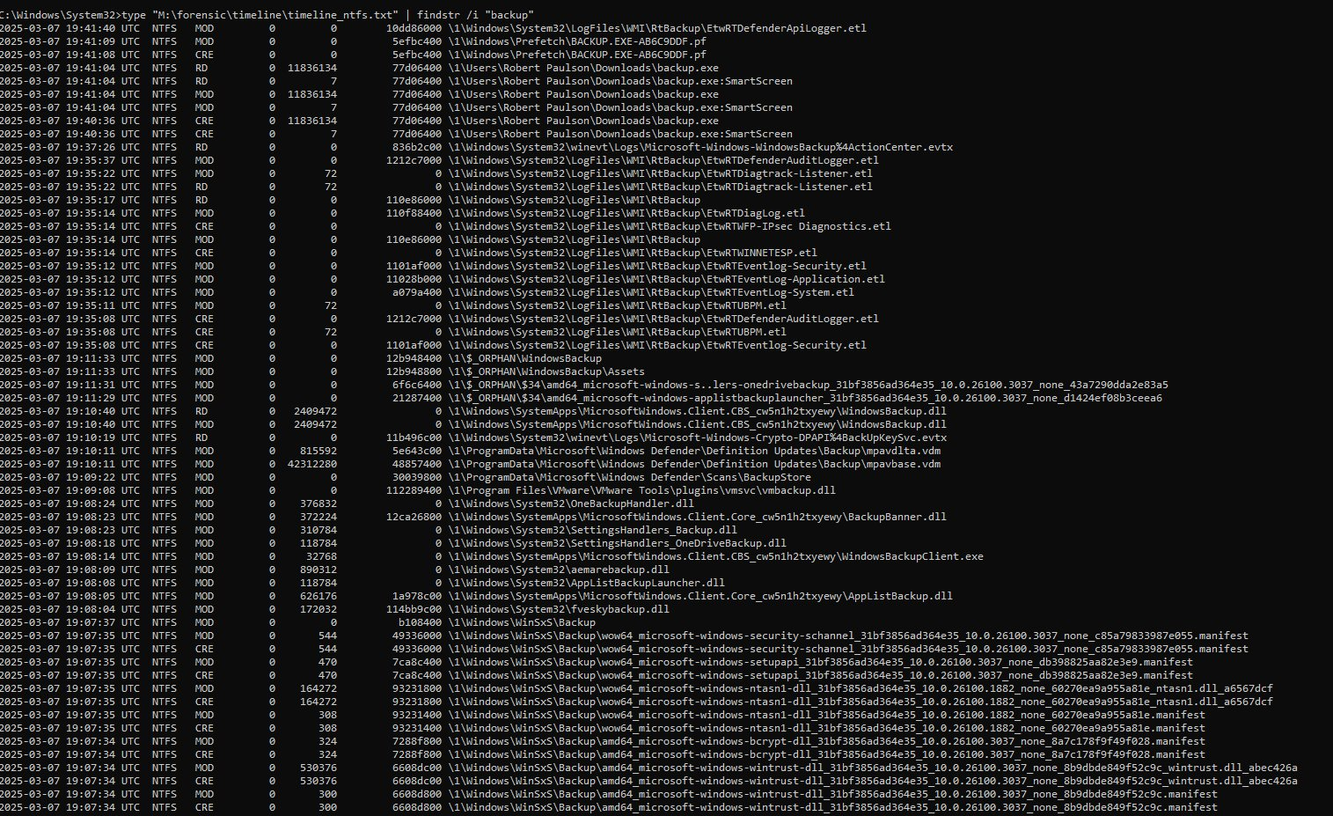
Figure 6 - MFT / Prefetch Timestamps (backup.exe and .pf file)

5.5 Encryption Activity — encryption_log.txt

The encryption log was created by backup.exe immediately upon execution. The file path on the victim's Desktop:
C:\Users\Robert Paulson\Desktop\encryption_log.txt

The file was empty when accessed via the live filesystem path (standard behaviour for a memory-resident write buffer), but was fully recoverable from the forensic files repository in MemProcFS:
M:\forensic\files\ROOT\Users\Robert Paulson\Desktop\ffffe00925170830-encryption_log.txt

The log confirmed that 9 files were encrypted by the ransomware.

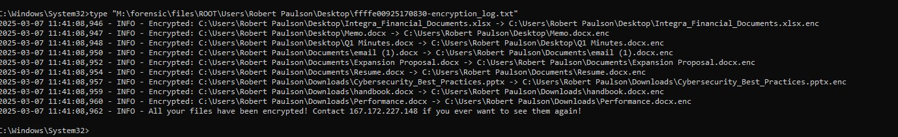
Figure 7 - encryption_log.txt Contents (9 encrypted files)

Finding: The encryption log provides direct evidence of the ransomware's impact — 9 user files encrypted, each logged with its full path. File created at 2025-03-07 19:41:09 UTC.

5.6 RSA Key Analysis — Public Key & Private Key Recovery

5.6.1 Public Key
The ransomware wrote the RSA public key to a temporary file during execution:
C:\Users\Robert Paulson\AppData\Local\Temp\tmp98p1q14j

The file contained a PEM-formatted 2048-bit RSA public key. This key was used by the ransomware to encrypt the session key, ensuring only the TA holding the private key could decrypt victim files.

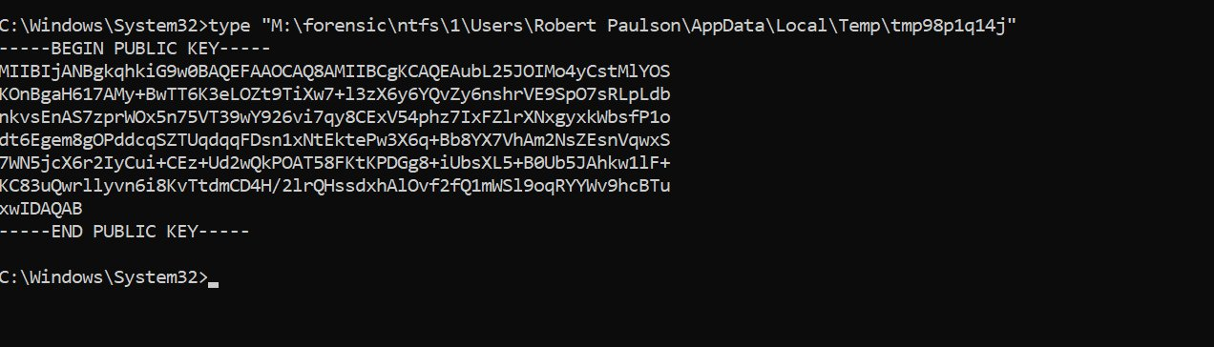
Figure 8 - RSA Public Key File (tmp98p1q14j)

5.6.2 Private Key Recovery from RAM
In the most significant forensic finding of this investigation, an RSA private key was recovered from volatile memory. The key appeared to remain resident in RAM because the ransomware process did not clear all key material before the dump was acquired:
$ grep 'BEGIN RSA PRIVATE KEY' memory.dmp -A 50 -B1 -a > priv1.key

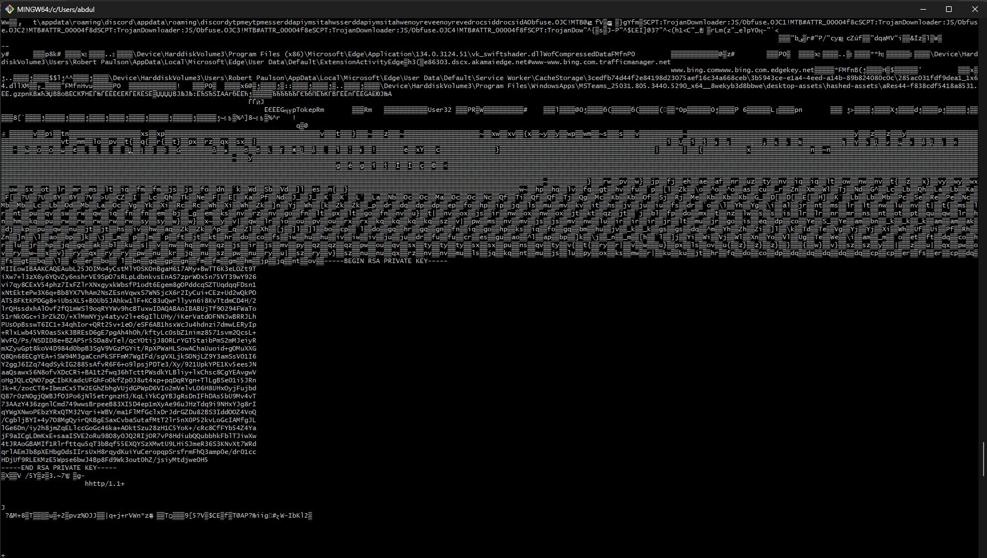
Figure 9 - RSA Private Key Extracted from memory.dmp

The recovered key was validated using OpenSSL to confirm it is a valid RSA private key and to test whether it matches the recovered public key. This verification supports the conclusion that the key may enable decryption if it matches the encryption process and the encrypted file format supports recovery:
$ openssl rsa -in priv1.key -check
RSA key ok
$ openssl dgst -sha256 -sign priv1.key -out signature.bin message.txt
$ openssl dgst -sha256 -verify pub.pem -signature signature.bin message.txt
Verified OK

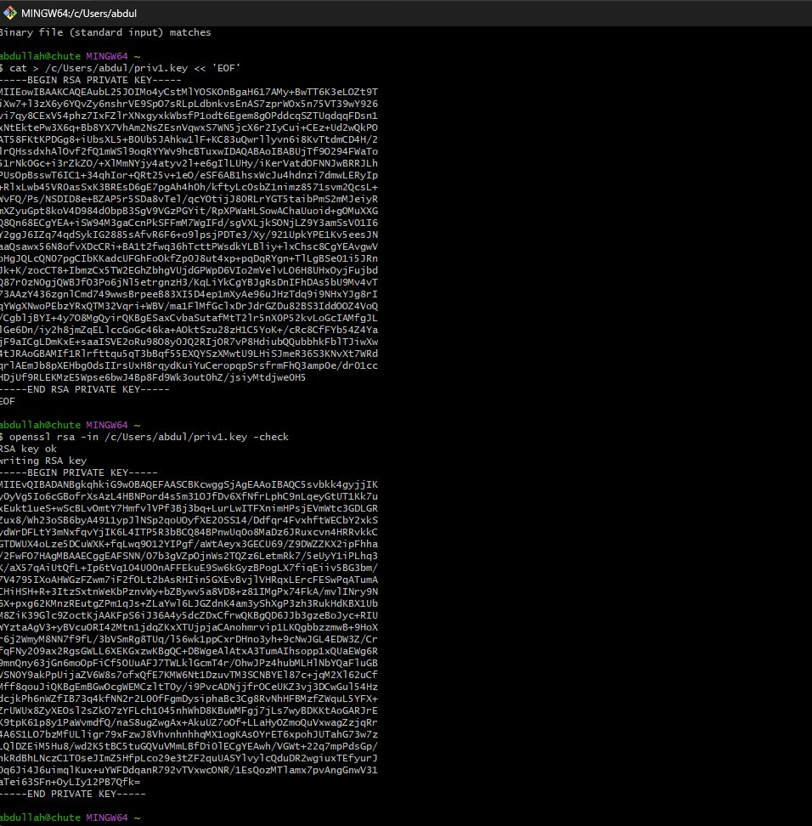
Figure 10 - OpenSSL Key Verification ('RSA key ok')

Critical Finding: An RSA private key was recovered from memory. This may enable decryption of affected files if the key matches the ransomware encryption routine and file format, but the report should not claim full file recovery unless actual decryption is demonstrated.

5.7 Browser History & Social Engineering Evidence

The victim's Microsoft Edge browsing history database was partially corrupted, but key content was recovered via hex analysis using HxD. The final recorded search query was:
Search query: "free backup utility for windows 11"

Content cached from the fake landing page was recovered from Edge's browser cache directory, revealing the social engineering mechanism. The page titled 'Backup Pro — Secure Your Files' explicitly instructed users to exclude C:\ from antivirus scanning before installation:
Title: Backup Pro - Secure Your Files
Body: Military-grade encryption and seamless backup solutions
Warning: Exclude C:/ from your AV scanning before installing
Download: <a href="backup.exe" download>Download Backup Pro</a>

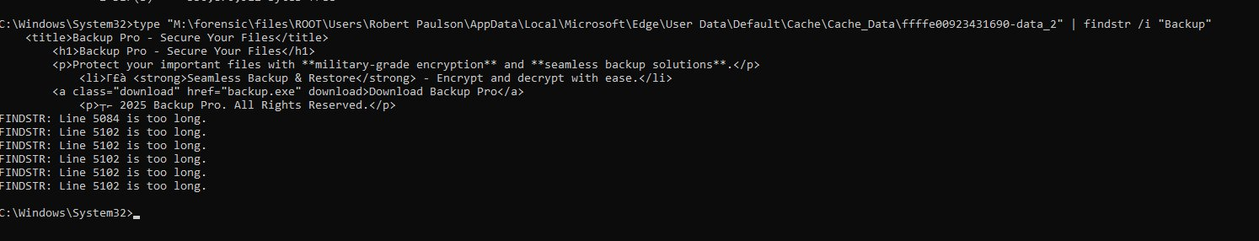
Figure 11 - Browser History / Cached Fake Landing Page

5.8 Summary of Key Findings

Finding | Detail | Severity
Hostname | RM-205B (confirmed via M:\sys\computername.txt) | HIGH
Primary User | Robert Paulson — SID: S-1-5-21-2126657629-3337008557-1579520640-1001 | HIGH
Victim IP Address | 10.0.2.152 (confirmed via netstat.txt) | HIGH
C2 Server IP — Download | 167.172.227.148:8080 — msedge.exe PID 8240 (CLOSED) — malware download | HIGH
C2 Server IP — Key Exchange | 167.172.227.148:80 — backup.exe (CLOSED) — RSA key exfiltration | HIGH
Malware File | backup.exe — C:\Users\Robert Paulson\Downloads\backup.exe — 11,836,134 bytes | HIGH
Defender Detection | Trojan:Win32/Wacatac.B!ml — 2025-03-07T19:37:27.387Z — MPSOURCE_IOAV | HIGH
Download URL | http://167.172.227.148:8080/backup.exe — confirmed via findevil.txt | HIGH
First Execution Time | 2025-03-07 19:41:08 UTC — BACKUP.EXE-AB6C9DDF.pf created (Prefetch) | HIGH
backup.exe Created on Disk | 2025-03-07 19:40:36 UTC — MFT CRE entry confirmed | HIGH
backup.exe Modified | 2025-03-07 19:41:04 UTC — MFT MOD entry (download complete) | HIGH
Files Encrypted | 9 files — Integra_Financial_Documents.xlsx, Memo.docx, Q1 Minutes.docx, email (1).docx, Expansion Proposal.docx, Resume.docx, Cybersecurity_Best_Practices.pptx, handbook.docx, Performance.docx | HIGH
Encryption Log Path | M:\forensic\files\ROOT\Users\Robert Paulson\Desktop\ffffe00925170830-encryption_log.txt | HIGH
Ransom Note (in log) | All your files have been encrypted! Contact 167.172.227.148 if you ever want to see them again! | HIGH
Encryption Timestamp | 2025-03-07 11:41:08.946 to 11:41:08.962 — all 9 files encrypted in under 20ms | HIGH
RSA Public Key Path | M:\forensic\ntfs\1\Users\Robert Paulson\AppData\Local\Temp\tmp98p1q14j | HIGH
RSA Private Key | Recovered from memory.dmp via grep — openssl rsa -check returned: RSA key ok | HIGH
Fake Landing Page | Title: Backup Pro - Secure Your Files — href: backup.exe download — cached in Edge | MEDIUM
Social Engineering Tactic | Fake site instructed user to exclude C:\ from AV scanning before installing | MEDIUM
Defender Warning Ignored | Trojan flagged at 19:37:27 UTC — user executed backup.exe at 19:41:08 UTC (3min 41sec later) | MEDIUM
OS of Victim Machine | Windows 10.0.26100 x64 (confirmed by MemProcFS on mount) | LOW

CONCLUSION AND COUNTERMEASURES

6.1 Conclusion

This investigation demonstrates how a combination of social engineering and user error led to a successful ransomware infection on the workstation of Robert Paulson (RM-205B). The victim downloaded and executed a malicious binary (backup.exe) from a threat actor-controlled server (167.172.227.148) after being deceived by a convincing fake software landing page.

The memory forensics analysis using MemProcFS reconstructed the attack timeline, identified indicators of compromise, recovered the encryption log, and extracted an RSA private key from volatile memory. The key recovery is significant because timely RAM acquisition may enable file recovery in ransomware cases, but only if the recovered key matches the encryption workflow and successful decryption is validated.

6.2 Countermeasures and Recommendations

6.2.1 Technical Controls
1. Enforce endpoint protection and EDR policies: Configure Microsoft Defender or an equivalent EDR so users cannot bypass quarantine warnings or add antivirus exclusions without administrator approval. Alert security teams whenever exclusions are created or Defender settings are weakened (Microsoft, 2025).
2. Block risky execution paths: Use Windows Defender Application Control, AppLocker, Software Restriction Policies, or Microsoft Defender Attack Surface Reduction rules to block unknown executables from Downloads, Temp, AppData/LocalAppData, browser cache folders, and archive extraction locations. This directly addresses the backup.exe execution path (Microsoft, 2026; FBI, 2021).
3. Network-level blocking: Use DNS filtering, secure web gateways, proxy inspection, and egress filtering to block direct outbound connections to suspicious IP addresses and unusual ports such as 8080. This would reduce malware delivery and C2 communication risk.
4. Ransomware-resilient backup strategy: Maintain offline or immutable backups using the 3-2-1 model. Backups must be isolated from ordinary user accounts so ransomware cannot encrypt backup copies (CISA et al., 2023).
5. Forensic readiness: Prepare incident response runbooks for rapid memory acquisition using approved tools. RAM should be captured before shutdown when ransomware is suspected because encryption keys, C2 connections, and process artefacts can disappear after reboot (Kent et al., 2006).
6. Preserve Prefetch rather than disabling it: Prefetch is mainly a forensic and performance artefact. It should not be treated as a primary prevention control. Prevention should focus on application control, EDR behavioural blocking, least privilege, and execution restrictions.

6.2.2 User Awareness Controls

1. Security awareness training: Train users to recognise social engineering tactics including fake download pages, unsolicited software installation prompts, and instructions to disable security software.
2. Phishing simulation exercises: Conduct regular simulated phishing and malicious download campaigns to test and reinforce employee vigilance.
3. Clear escalation procedures: Ensure users know to report suspicious downloads and Defender alerts to the IT security team immediately rather than dismissing them.

6.2.3 Incident Response Controls

1. Establish an Incident Response Plan (IRP): Define clear roles, communication chains, evidence handling, containment steps, and escalation procedures. NIST incident handling guidance recommends structured preparation, detection and analysis, containment, eradication, recovery, and post-incident activity (Cichonski et al., 2012).
2. Isolate infected hosts immediately: On detection of ransomware activity, isolate the affected machine from the network to prevent lateral movement and further encryption.
3. Preserve volatile memory before shutdown: Memory forensics may recover encryption keys or C2 artefacts. Image RAM before powering down an infected host when it is safe and within the response plan.

REFERENCES
13Cubed. (2025). Windows Memory Forensics Challenge. iBlue Team. https://www.iblue.team/ctf-challenges/13cubed-windows-memory-forensics
13Cubed Training. (2025). Memory forensics challenge [Video]. YouTube. https://www.youtube.com/watch?v=6JN6iAenEoA
Cichonski, P., Millar, T., Grance, T., & Scarfone, K. (2012). Computer security incident handling guide (NIST SP 800-61 Rev. 2). National Institute of Standards and Technology. https://csrc.nist.gov/pubs/sp/800/61/r2/final
Cybersecurity and Infrastructure Security Agency, National Security Agency, Federal Bureau of Investigation, & Multi-State Information Sharing and Analysis Center. (2023). #StopRansomware guide. https://media.defense.gov/2023/May/23/2003227891/-1/-1/1/CSI-StopRansomware-Guide.PDF
Federal Bureau of Investigation. (2021). DarkSide ransomware: Best practices for preventing business disruption from ransomware attacks. https://www.ic3.gov/CSA/2021/210520.pdf
Kent, K., Chevalier, S., Grance, T., & Dang, H. (2006). Guide to integrating forensic techniques into incident response (NIST SP 800-86). National Institute of Standards and Technology. https://csrc.nist.gov/pubs/sp/800/86/final
Microsoft. (2025). Microsoft Defender Antivirus in Windows overview. Microsoft Learn. https://learn.microsoft.com/en-us/defender-endpoint/microsoft-defender-antivirus-windows
Microsoft. (2026). Attack surface reduction rules reference. Microsoft Learn. https://learn.microsoft.com/en-us/defender-endpoint/attack-surface-reduction-rules-reference
SANS Internet Storm Center. (2023). Prefetch files in Windows forensics. https://isc.sans.edu/diary/29168
ufrisk. (2026). MemProcFS: The Memory Process File System. GitHub. https://github.com/ufrisk/MemProcFS
Volatility Foundation. (2026). Volatility 3 documentation. Read the Docs. https://volatility3.readthedocs.io/

APPENDICES

Appendix A: Indicators of Compromise (IOC) Summary
IOC Type | Value | Context
IP Address | 167.172.227.148 | C2 server — malware delivery & key exfil
Port | 8080 (TCP) | Malware download port
Port | 80 (TCP) | Key exfiltration port
File Hash Path | C:\Users\Robert Paulson\Downloads\backup.exe | Ransomware binary
File Path | C:\Users\Robert Paulson\AppData\Local\Temp\tmp98p1q14j | RSA Public Key
File Path | C:\Users\Robert Paulson\Desktop\encryption_log.txt | Encryption activity log
URL | http://167.172.227.148:8080/backup.exe | Malware delivery URL
Hostname | RM-205B | Victim machine
Username | Robert Paulson | Victim user account
Defender Sig | Trojan:Win32/Wacatac.B!ml | AV detection signature

